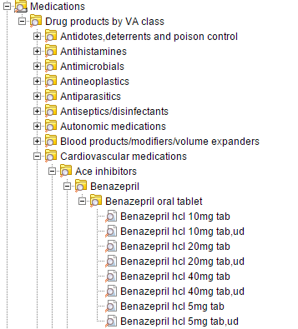

VA hierarchy

RxNorm IN

RxNorm SCDF

(ingred. + dose form)

RxNorm SCD & SBD

(ingred. + strength + dose form)

**Text information on medications**

Textbook

AHFS (American Hospital Formulary Service)

AHFS Pharmacologic Therapeutic Classification, see <http://resourcecenter.ovid.com/site/products/fieldguide/ipab/List_of_AHFS_Pharmacologic-.jsp>

AHFS Drug Information (2018) book is available (<http://online.statref.com> search for AHFS)

Medication package inserts

Download data from Dailymed: <https://dailymed.nlm.nih.gov/dailymed/>

Richard Boyce has a local database <https://dbmi-icode-01.dbmi.pitt.edu/linkedSPLs/>

**Discrete information on medications**

Knowledgebase is RxNorm <https://www.nlm.nih.gov/research/umls/rxnorm/>

Paper with RxNorm description <https://www.thieme-connect.com/products/ejournals/pdf/10.1055/s-0038-1667077.pdf>

Existing classification systems <https://mor.nlm.nih.gov/RxClass/>

**Properties / axes of medications that are usually present in medication package inserts**

**Indications** – diseases and conditions for which the drug is to be used

**Contraindications** – diseases and conditions for which the drug is not to be used

**Adverse reactions** – diseases and conditions that the drug can cause

**Non-clinical toxicology** – effects related to carcinogenicity, fertility, animal toxicology

**Drug-drug interactions** – other medications with which this medication can interact

**Description** – how and where the drug acts; usually includes Mechanism of action (MoA), Physiologic effect (PE) and Chemical / ingredient

* Mechanism of action (MoA)
* Physiologic effect (PE)
* Chemical / ingredient

**Dosage and administratio**n – includes dosage form and strengths

**Use in specific populations**

**Clinical pharmacology** – included the following topics

* Mechanism of action (MoA)
* Pharmacokinetics - what drugs do to the body and how
* Pharmacodynamics - what happens to the drug while in the body; includes absorption, distribution, metabolism, excretion